1. **SELECT**: Retrieve all columns from the Doctor table.

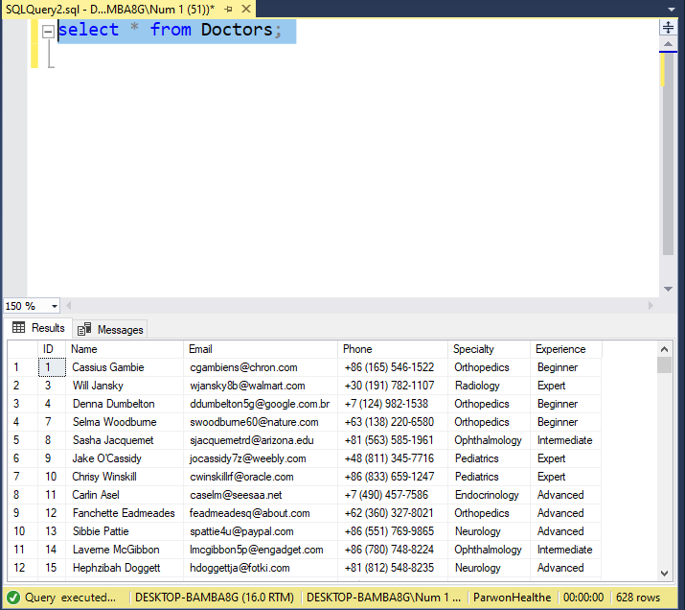

1. **ORDER BY**: List patients in the Patient table in ascending order of their ages. 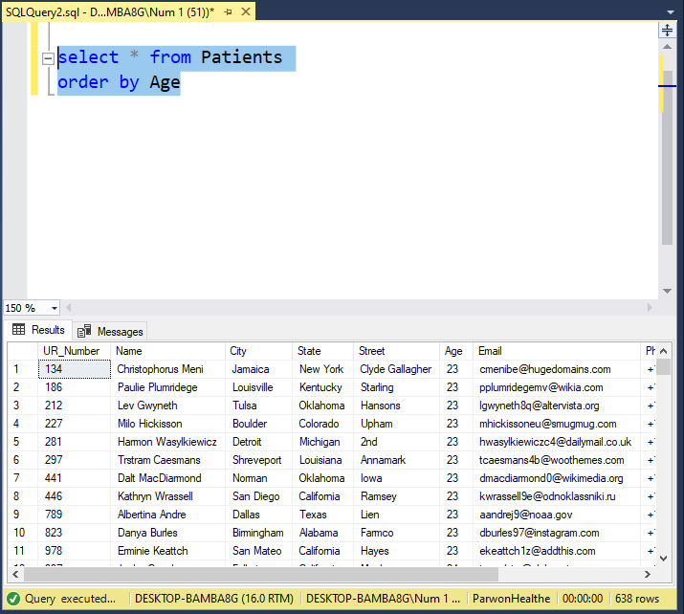
2. **OFFSET FETCH**: Retrieve the first 10 patients from the Patient table, starting from the 5th record.

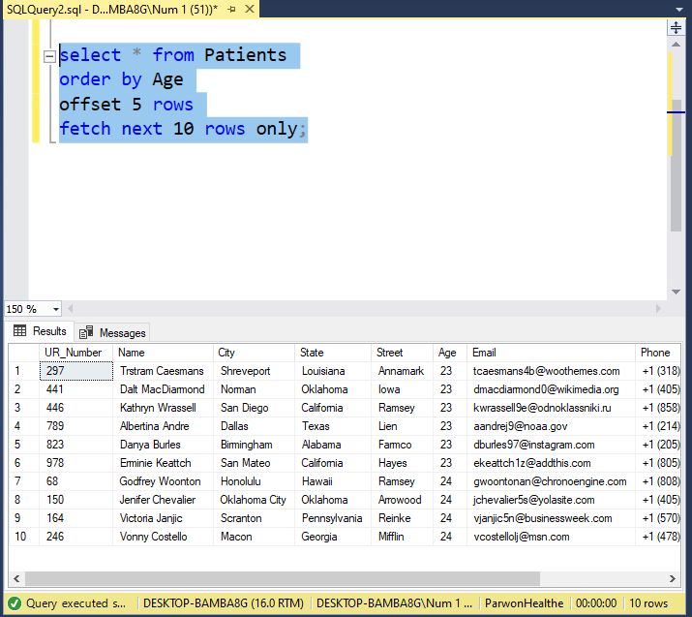

1. **SELECT TOP**: Retrieve the top 5 doctors from the Doctor table. 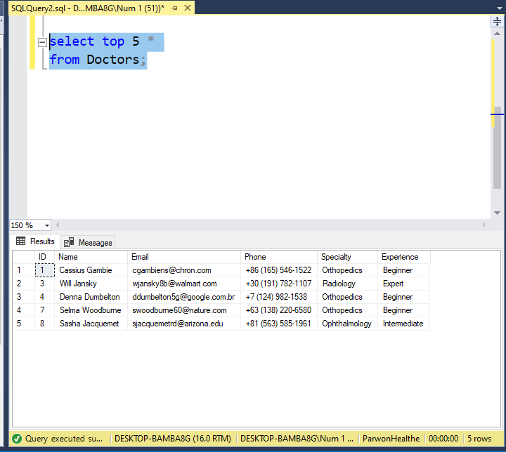
2. **SELECT DISTINCT**: Get a list of unique address from the Patient table.

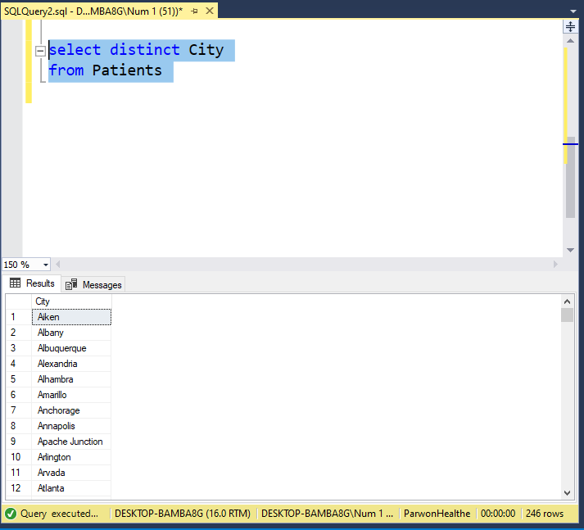

1. **WHERE**: Retrieve patients from the Patient table who are aged 25.

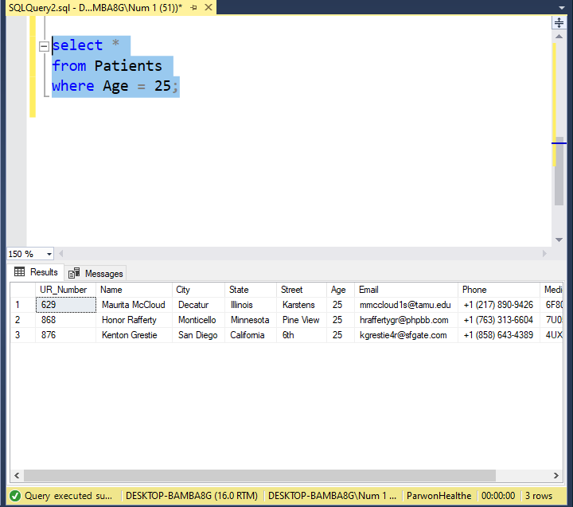

1. **NULL**: Retrieve patients from the Patient table whose email is not provided.

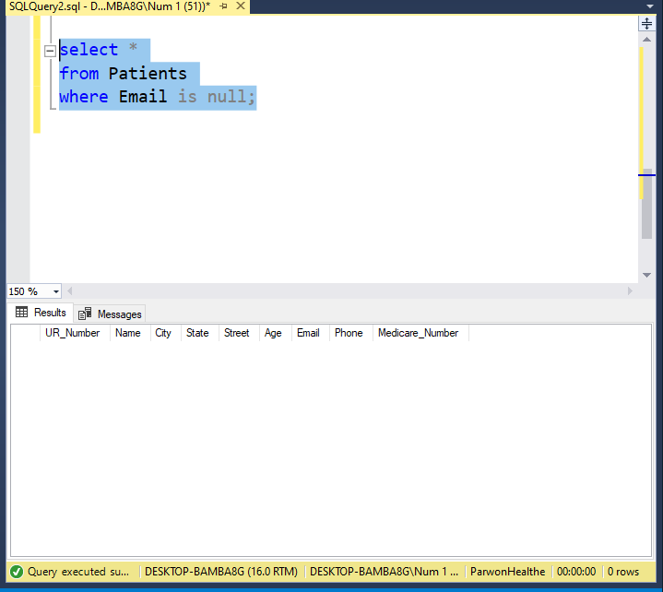

1. **AND**: Retrieve doctors from the Doctor table who have experience greater than 5 years and specialize in 'Cardiology'.

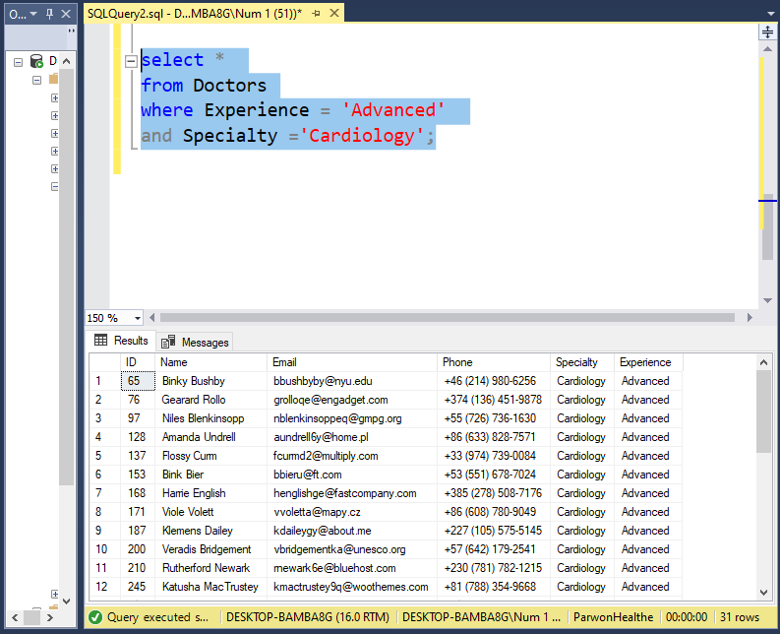

1. **IN**: Retrieve doctors from the Doctor table whose speciality is either Cardiology or Ophthalmology.

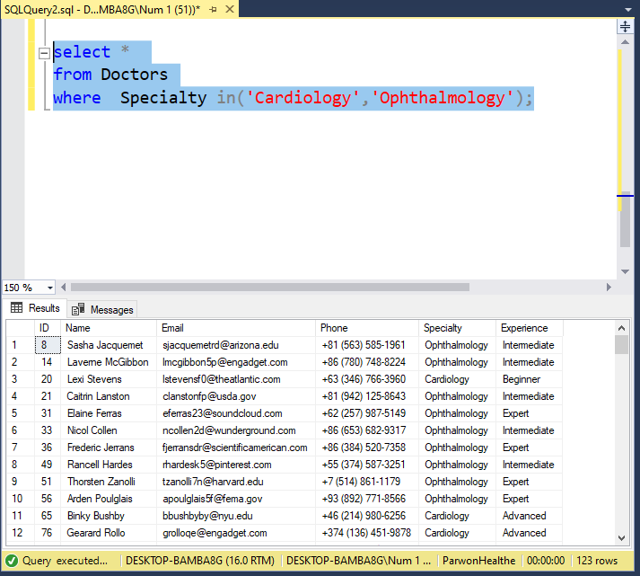

1. **BETWEEN**: Retrieve patients from the Patient table whose ages are between 23 and 32.

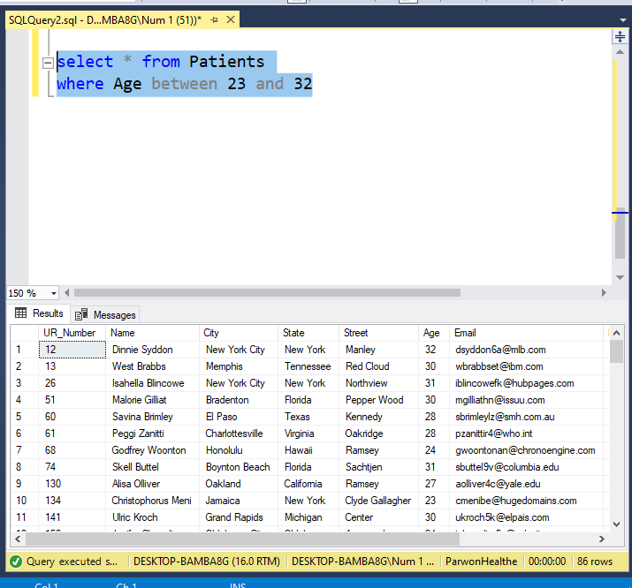

1. **LIKE**: Retrieve doctors from the Doctor table whose names start with 'Dr.'.

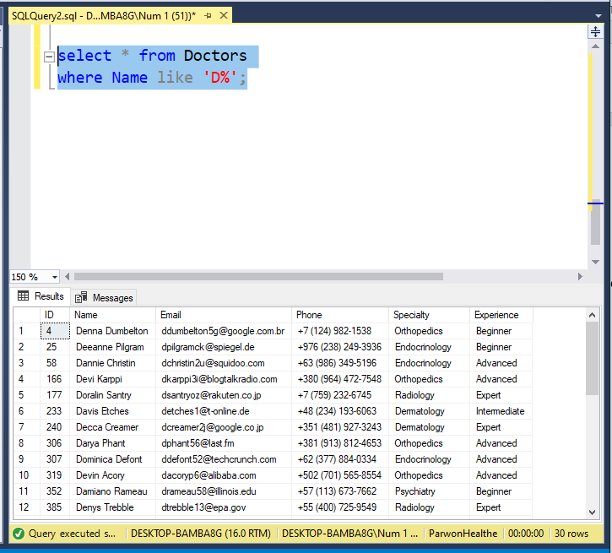

1. **Column & Table Aliases**: Select the name and email of doctors, aliasing them as 'DoctorName' and 'DoctorEmail'

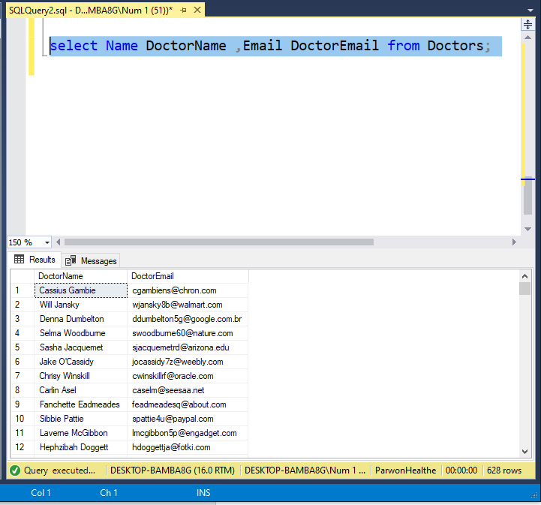

1. **Joins**: Retrieve all prescriptions with corresponding patient names.

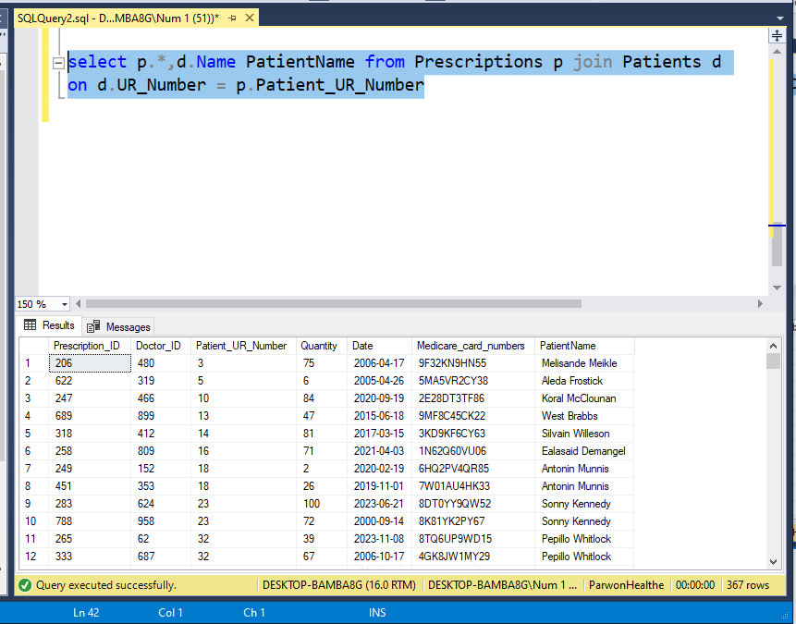

1. **GROUP BY:** Retrieve the count of patients grouped by their cities.

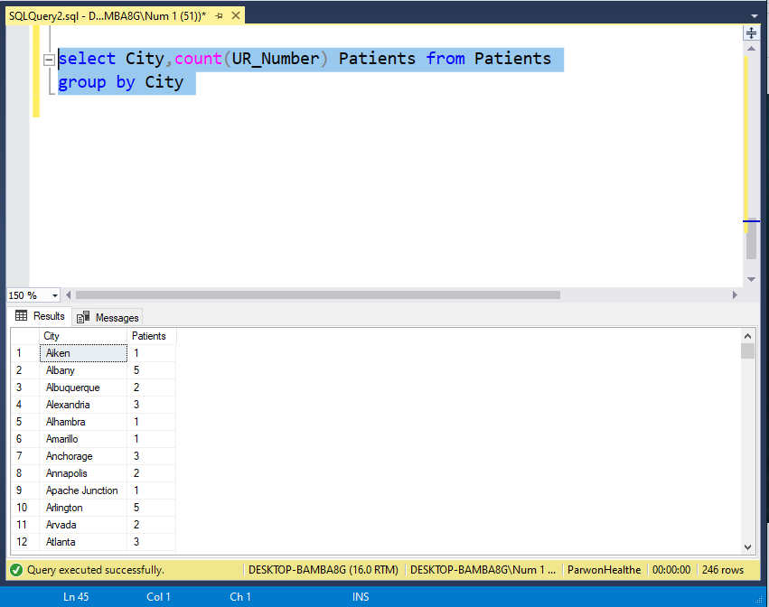

1. **HAVING:** Retrieve cities with more than 3 patients.

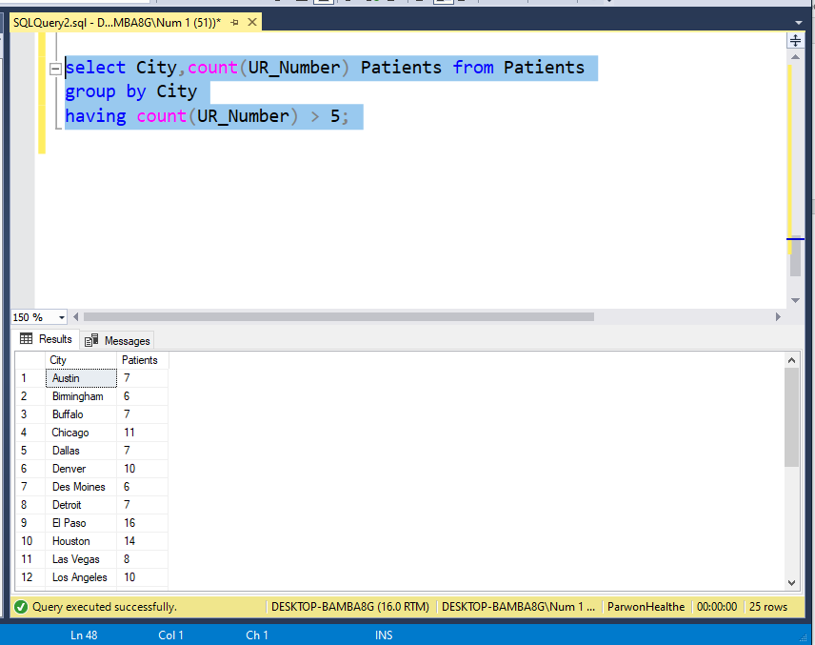

1. **GROUPING SETS:** Retrieve counts of patients grouped by cities and ages.

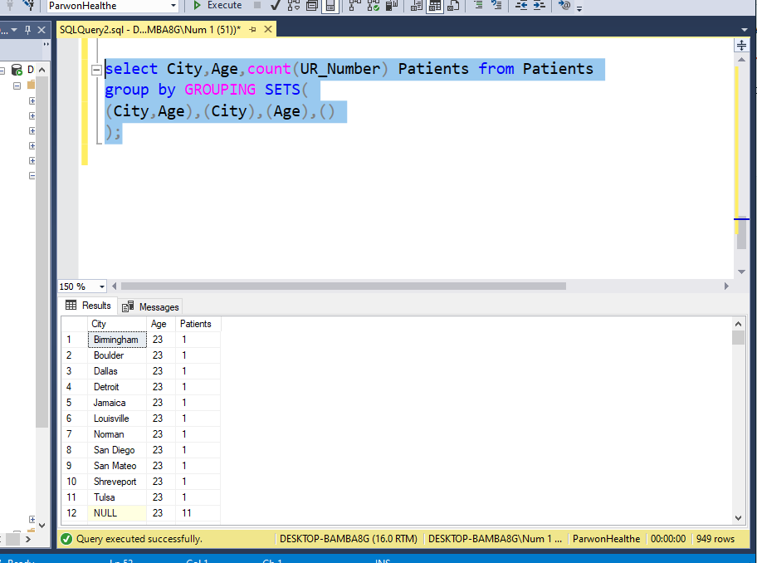

1. **CUBE:** Retrieve counts of patients considering all possible combinations of city and age.

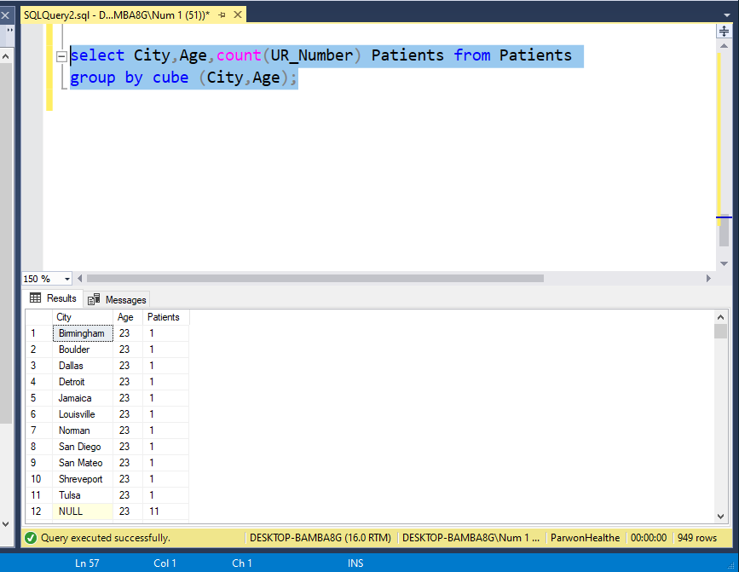

1. **ROLLUP:** Retrieve counts of patients rolled up by city.

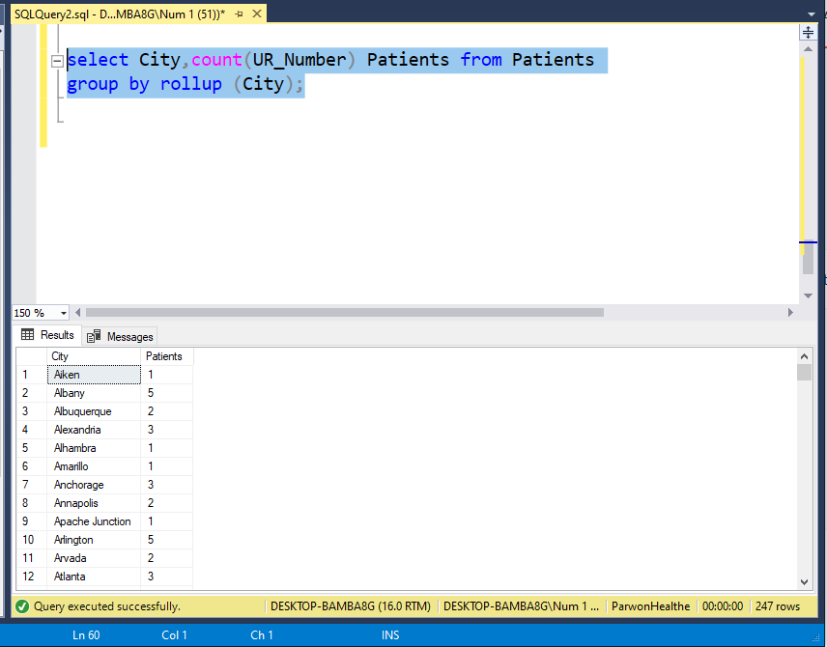

1. **EXISTS**: Retrieve patients who have at least one prescription.

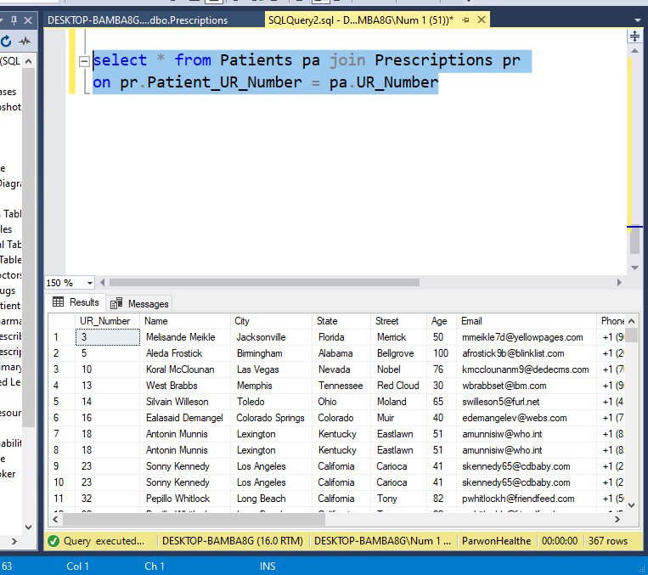

1. **UNION:** Retrieve a combined list of doctors and patients.

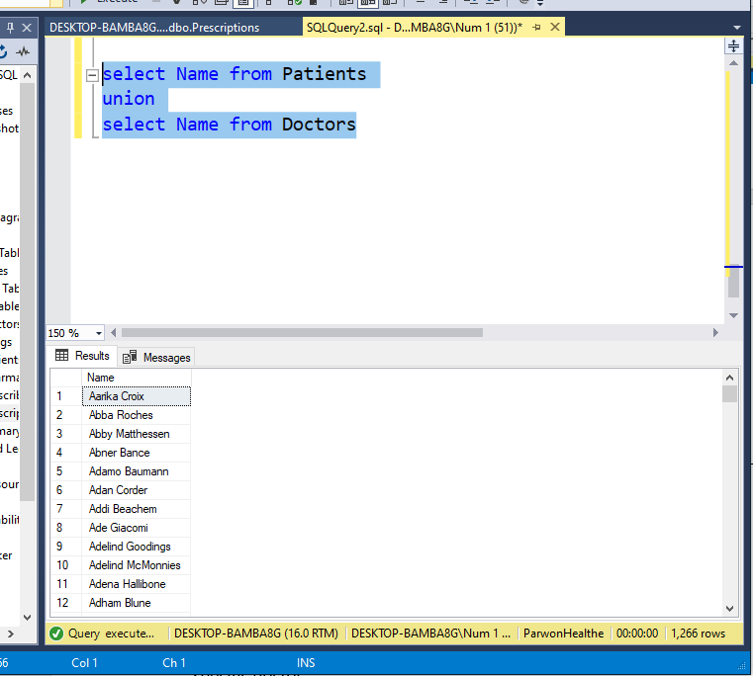

1. **Common Table Expression (CTE):** Retrieve patients along with their doctors using a CTE.
2. **INSERT:** Insert a new doctor into the Doctor table.

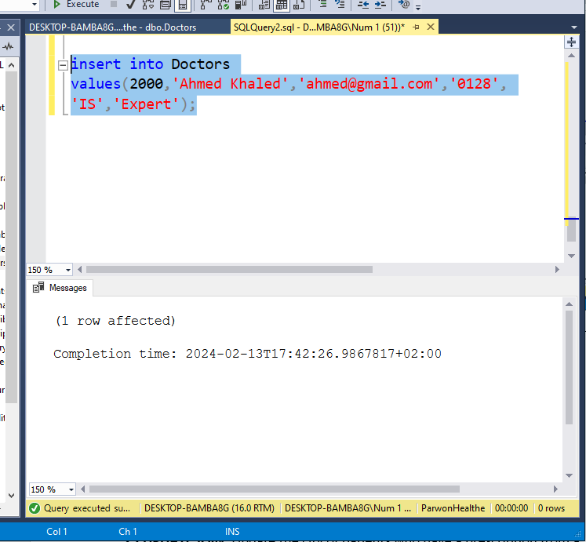

1. **INSERT Multiple Rows:** Insert multiple patients into the Patient table.

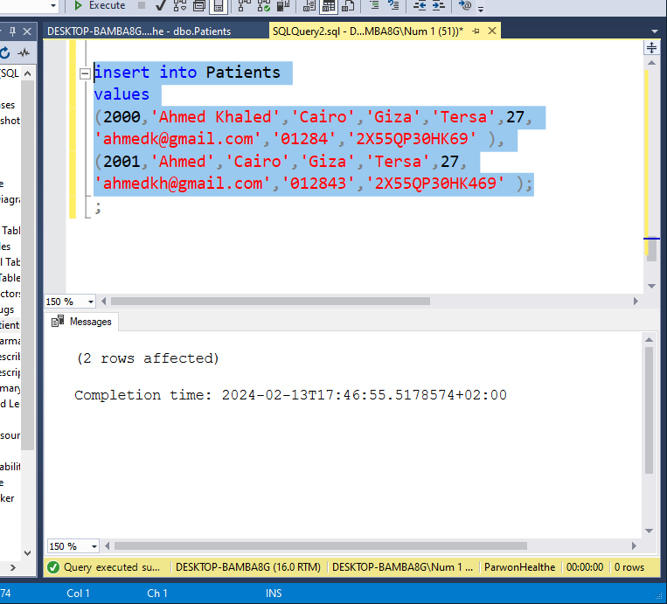

1. **UPDATE:** Update the phone number of a doctor.

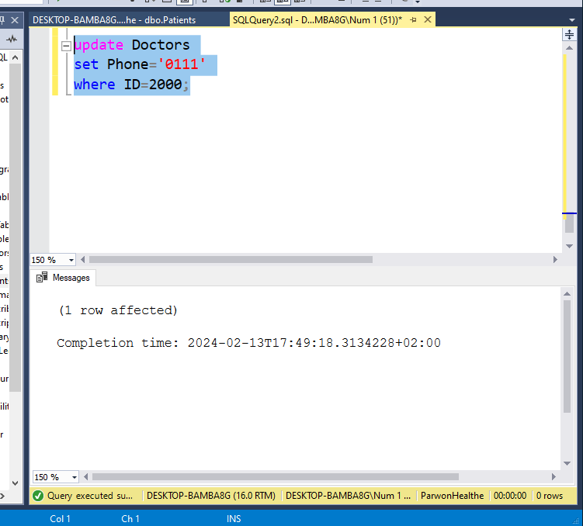

1. **UPDATE JOIN:** Update the city of patients who have a prescription from a specific doctor.
2. **DELETE:** Delete a patient from the Patient table.

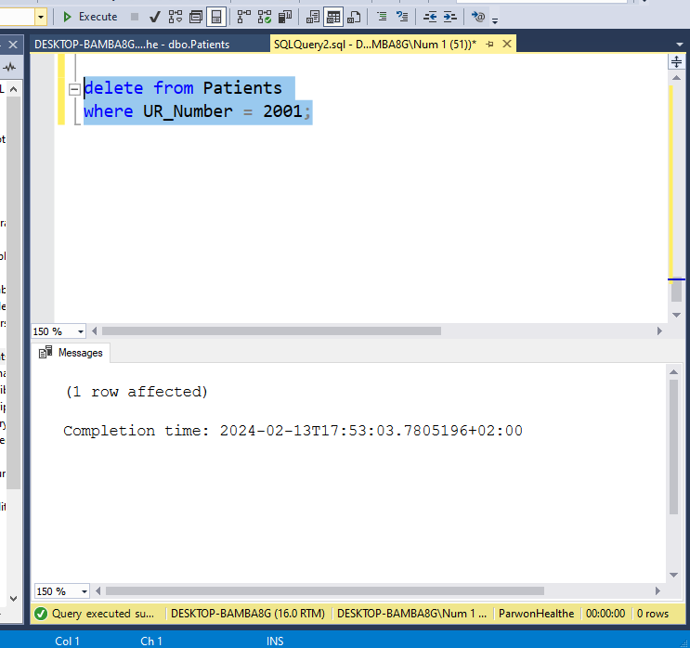

1. **Transaction:** Insert a new doctor and a patient, ensuring both operations succeed or fail together.
2. **View:** Create a view that combines patient and doctor information for easy access.
3. **Index:** Create an index on the 'phone' column of the Patient table to improve search performance.
4. **Backup:** Perform a backup of the entire database to ensure data safety.